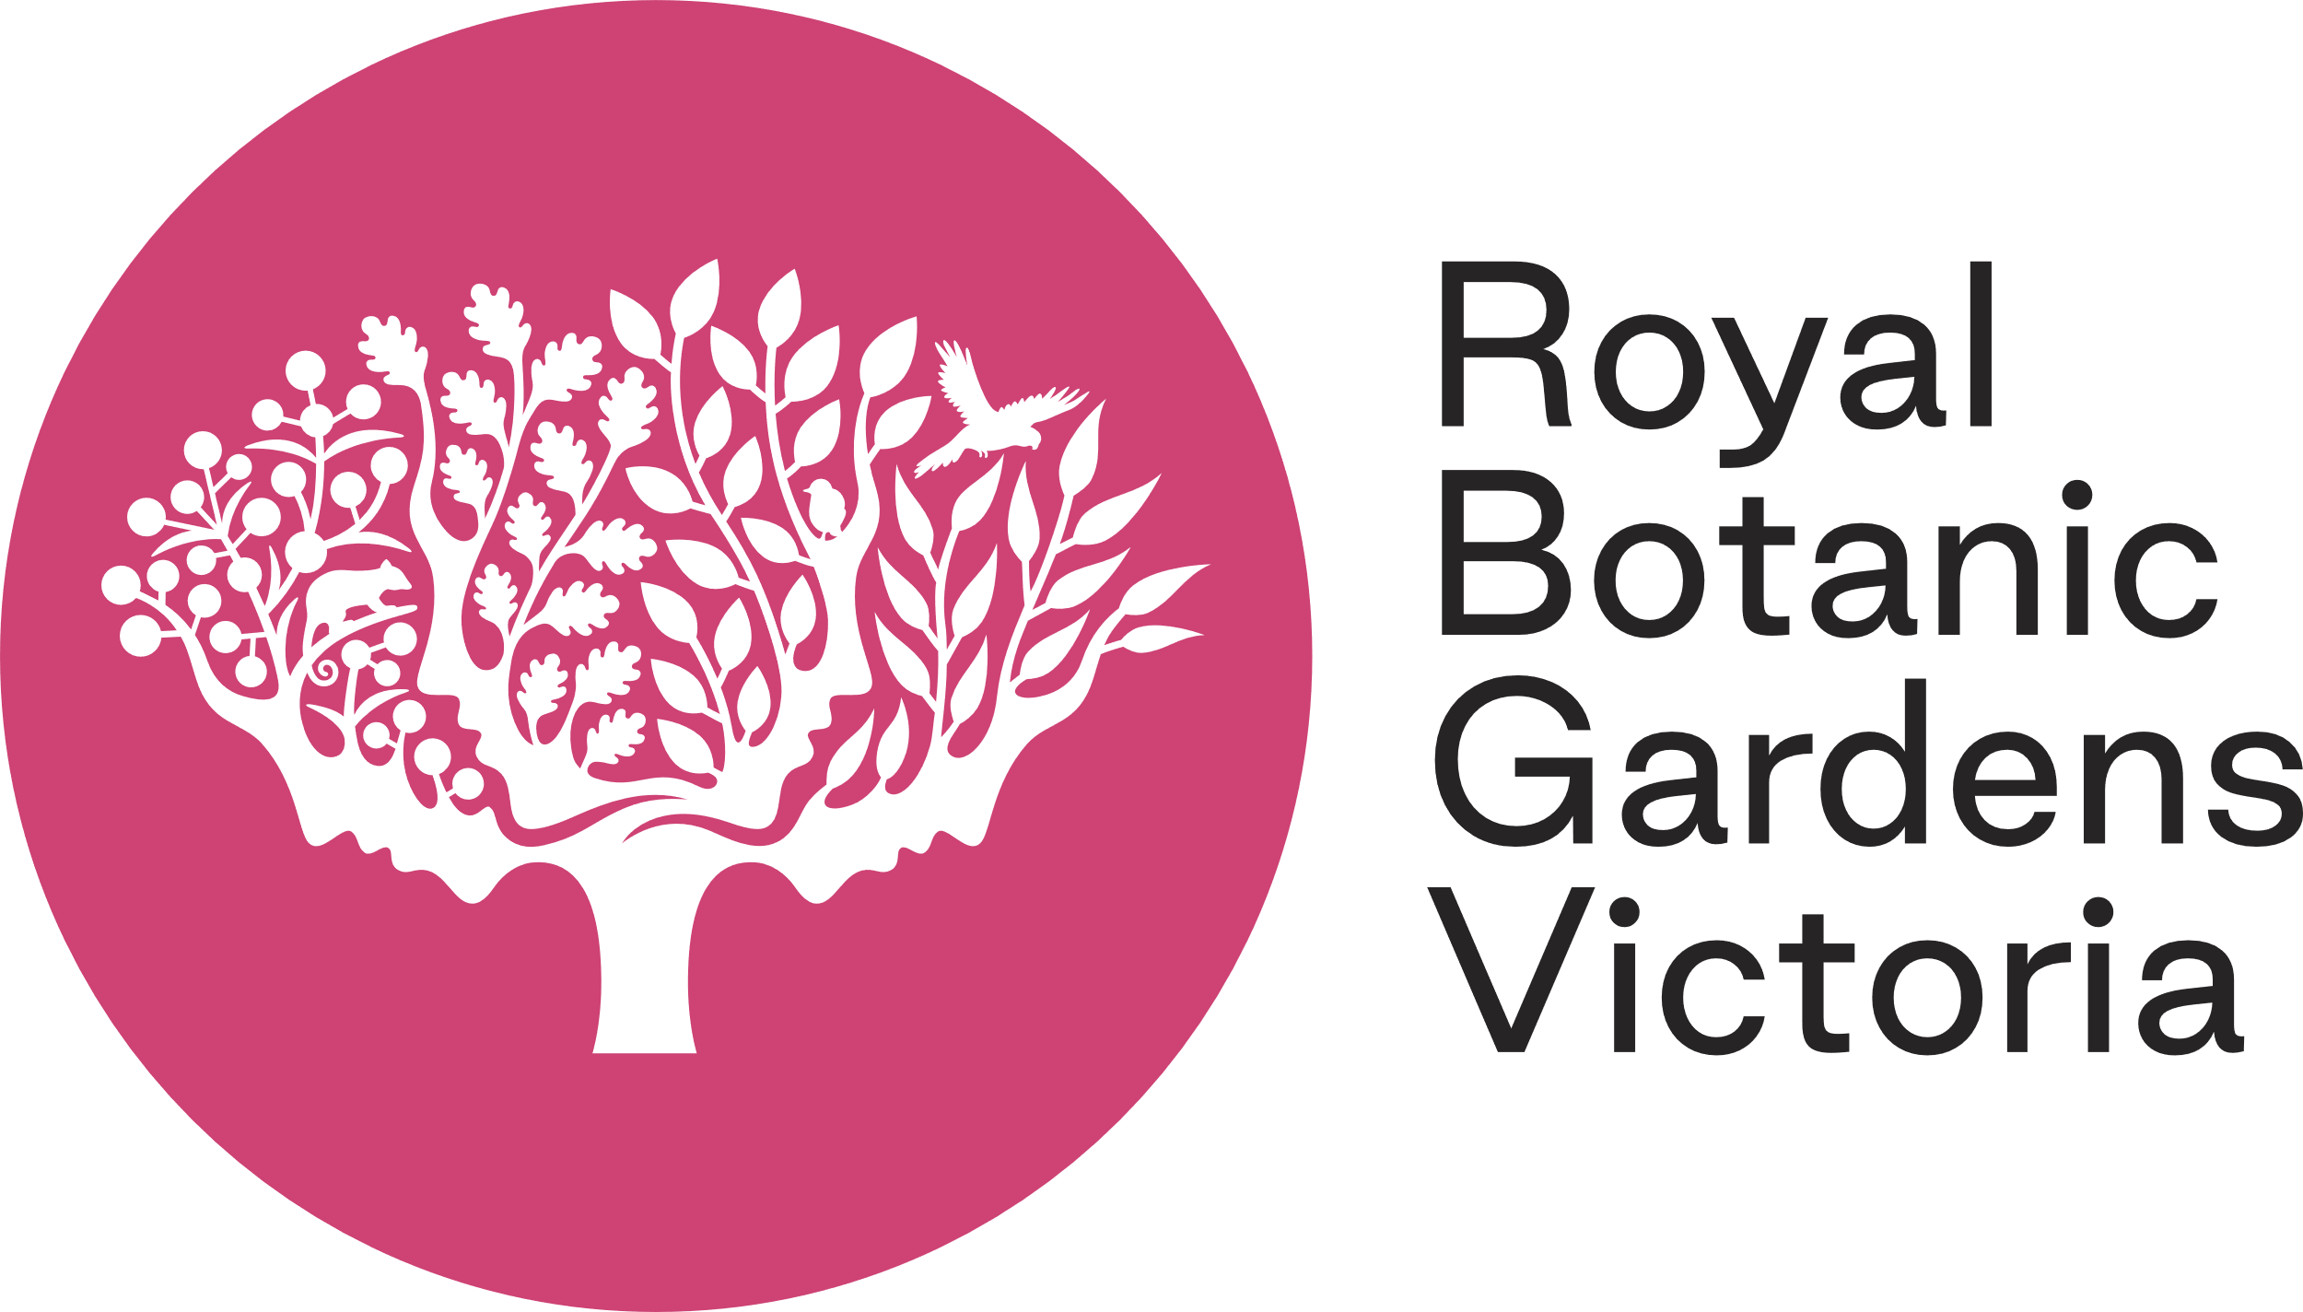
2023 Learning Program Booking Terms and Conditions
As at November 2022

Program enquiries and bookings

Enquiries and booking requests can be made with the Schools Administrator via the RBGV Excursion Booking Request Form.

- Phone: 03 9252 2358
- Email: learning@rbg.vic.gov.au

Booking confirmation

Bookings are not confirmed until an official booking confirmation is issued from Royal Botanic Gardens Victoria.

Cost and Supervision
Year Level | 2023 Program Fee  (inc. GST) | Adult-Student Ratio
Early Childhood | $15.00 per student | 1:3
Foundation – Year 2 | $15.00 per student | 1:5
Year 3 - 12 | $15.00 per student | 1:10

Minimum Fee

The minimum fee for a Learning Program is $270.00 (inc. GST), equivalent to a minimum charge of 18 students. Exceptions to the minimum fee may apply to Special Development Schools and RBGV Partnership Programs.

Confirmed Attendances

The confirmed number of students attending a program is required 24 hours prior to your booked program. This is the minimum number for which charges will apply.

Invoice and Payment

A Tax Invoice, reflecting confirmed student numbers (or the actual number of students should this number increase) will be sent to the school following the program. Payment of invoices is via bank transfer and is required within 14 days of receipt.

Cancellations

Cancellation of a program must be made at least 3 business days prior to the booked program. If not, a cancellation fee of $270 per class will be invoiced to the school. The fee does not apply in the circumstances of extreme weather, RBGV cancellations or if the booking can be rescheduled.

RBGV Program Cancellations

On rare occasions Royal Botanic Gardens Victoria may be required to cancel a program due to circumstances beyond our control (e.g. extreme weather conditions). In such circumstances Royal Botanic Gardens Victoria will prioritise rescheduling of the program to a mutually agreeable date. Extreme weather may include dangerous winds, storms or heat.

